CSC 134 Spring 2019
Assignment 5
Total: 100 points

This homework allows students to practice the development of a database using MySQL.
Section 1
Using SQL, create tables according to the given schema shown in Figure 1. Note that this section is exactly the same as the one in Assignment 4. You can use your Assignment 4 directly, or modify your Assignment 4 (if needed). The type of each attribute is defined in Figure 2. Note that it is case-sensitive.

Branch (name, address)
Customer (ssn, fname, lname, phone, address, fv_branch) foreign key (fv_branch) references Branch (name)
Account (acc_no, balance, open_date, atype)
Owns( ssn, acc_no, own_date) foreign key (ssn) references Customer(ssn), foreign key (acc_no) references Account (acc_no)
Loan( loan_no, amount, ltype)
Payment ( loan_no, payment_no, amount, method, status, due_date) foreign key(loan_no) references Loan(loan_no)
Borrows(ssn, loan_no) foreign key (ssn) references Customer(ssn), foreign key (loan_no) references Loan (loan_no)
Figure 1 Schema

Branch (name: VARCHAR(25), address: VARCHAR(50))
Customer (ssn: CHAR(9), fname: VARCHAR(25), lname: VARCHAR (25) , phone CHAR(10), address: VARCHAR (50), fv_branch: VARCHAR(25) )
Account (acc_no: CHAR(9), balance: DECIMAL (15,2), open_date: DATE, atype: VARCHAR(10))
Owns( ssn: CHAR(9), acc_no: CHAR(9), own_date: DATE) foreign key (ssn) references customer(ssn), foreign key (acc_no) references account (acc_no)
Note: DATE is in the format of ‘yyyy-mm-dd’.
Loan( loan_no: CHAR(9), amount: DECIMAL(15,2), ltype: VARCHAR(10))
Payment ( loan_no: CHAR(9), payment_no: CHAR(4), amount: DECIMAL(15,2), method: VARCHAR(10), status: VARCHAR(10), due_date: DATE) foreign key(loan_no) references loan(loan_no)
Borrows(ssn: CHAR(9), loan_no: CHAR(9)) foreign key (ssn) references customer(ssn), foreign key (loan_no) references loan (loan_no)
Figure 2 Schema with type

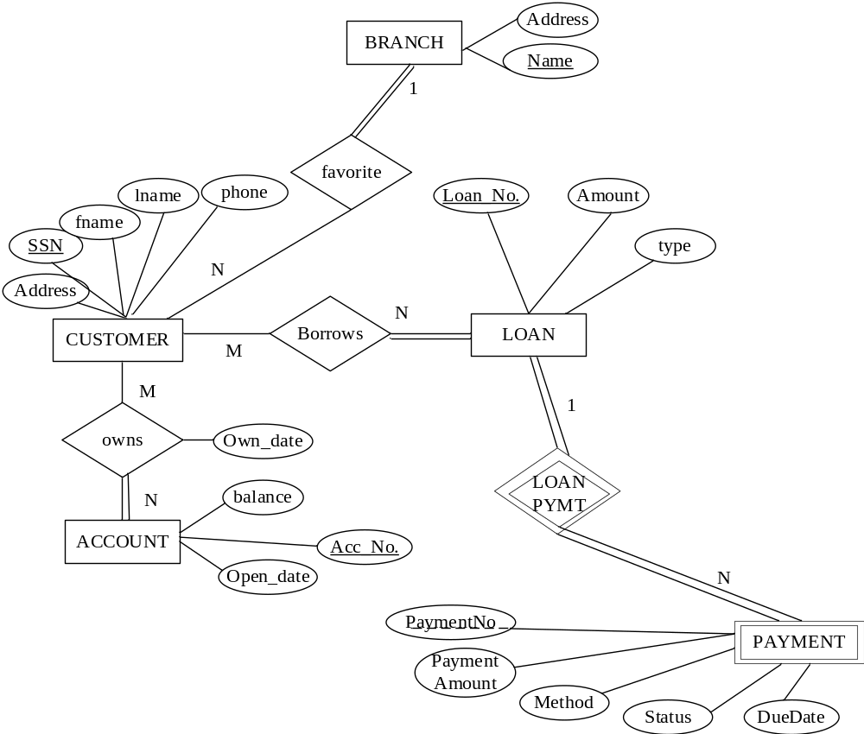
Figure 3 ER Diagram

Section 2
Populate the database. Please check sections 3 for details.

Section 3
Use SQL to specify the following queries. When you populate the database, insert data such that at least one row will be display as the result of running each query.
- List each the loan payment (loan_no, payment_no, amount, method) that was paid and the payment was less than $15, order the result by loan_no. (once a payment is done, the status of the payment will be “Paid”)
- List all the customers (ssn, first name, last name) who have at least one account with balance more than $10000. Don’t list a customer twice if he/she has more than one account satisfy the condition.
- List all customers (ssn, first name, last name) who own less than 3 accounts.
- List all the customers (ssn, first name, last name, phone number) who own account ‘000000001’.
- List each the loan payment (payment no, due_date) of “John Smith” that has been paid by check.
- List each the customer (ssn, first name, last name) who has at least one loan. List a customer only once even if the customer has more than two loan.
- Retrieve all the loans that “John Smith” has. If a loan is shared by him and other customers, you should count it in. Please list John’s ssn and number of loans he has.
- Retrieve the total account balance of a customer if a customer has more than 2 accounts. If an account is shared, you should also count it in. List ssn, number of accounts, and total balance.
- List each customer with his/her favorite branch (customer SSN, Customer Last Name, Branch Name, Branch address). If a customer does not have a favorite branch, then the branch name and branch address should be NULL.

Section 4
Specify the statements to drop all the tables. Pay attention to the order of the drop statements in order to drop everything successfully. Note that this section is exactly the same as the one in Assignment 4. You can use your assignment 4 directly, or modify your assignment 4 (if needed).

Submission

Submit the following files to Canvas. Note: Submit through any other ways, such as email attachment, will not be graded. Do NOT zip them.
- *Create table statements (file name must be: 1_create_table.txt)
- Insert statements to populate database (file name must be : 2_populate_db.txt)
- Queries (file name must be: 3_query.txtl)
- *Statements to drop all tables (file name must be: 4_drop_all.txt)
- An output file showing query results (file name must be: 5_output.pdf). In this file, for each query, you must:
  - Include the number and query description (e.g Query 1: List each the loan payment ….)
  - Your SQL query (e.g. select… from…)
  - The result of running this query (screen shots).
Note: 1* and 4* can be the same as the ones that you submitted for Assignment 4.

